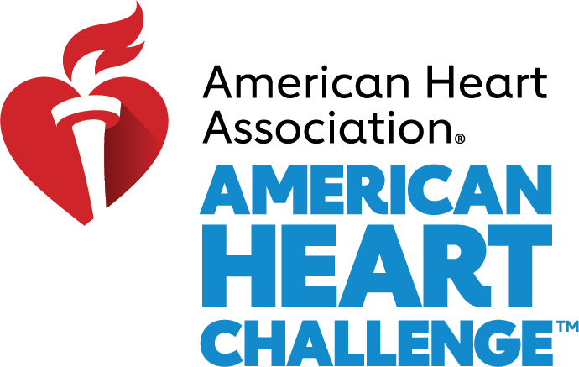

Our District will be going Red on February 5th!

Cardiovascular disease accounts for 1 of every 3 deaths in the United States, touching the hearts of nearly every family in every community. Show your support and donate $20 to receive your commemorative Go Red shirt. Your donation saves lives!

DEADLINE: T-Shirts must be ordered by Monday, January 18th to receive them in time for National Wear RED Day.
HOW TO ORDER: To make your $20 donation, simply text EASTPOINTEGIVES to 41444.
You will immediately receive a link to a quick donation form!

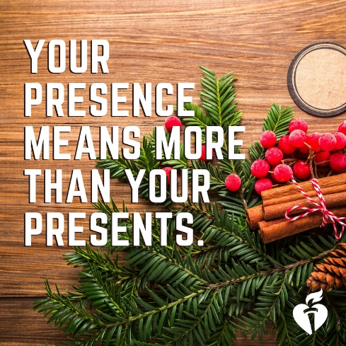
Happy Holidays!

If the holidays sometimes leave you feeling overwhelmed and out of control, you are not alone!

Here are some key things you can do to stay happy and healthy throughout the busy holiday season.

Try our Top 5 Tips for a Healthy Holiday Season

District Heart Challenge – VIRTUAL

Click on the image to enter the virtual living room and learn easy ways you can sleep better, manage holiday stress, and even try a yoga workout!

The American Heart Association heart torch icons will guide you through topics including how to get energy when you’re too tired, how pets can help you live longer, tips for better sleep, move more together yoga, and tips for loving-kindness meditation.

CHALLENGE: Holidays can be both wonderful and stressful. Challenge yourself this month to take up yoga or meditation! Be sure to check out more Tips to Lower Stress.

MONTHLY RECIPES  Pork Tenderloin stuffed with Spinach | INFOGRAPHICS  How to Sleep Better  Loving-Kindness Meditation  How to Get Energy When You’re Too Tired to Work out

