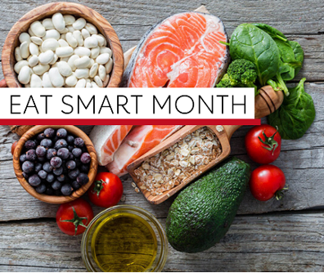
November is Eat Smart Month!

Throughout the month, we encourage everyone to take the first step to commit to healthier eating. Making small, simple changes today can create a difference for generations to come.

Stay smart this holiday season with these simple tips.

District Heart Challenge – VIRTUAL
Click on the image to enter the Virtual Kitchen and learn easy ways you can improve your diet and overall eating habits.

The American Heart Association heart torch icons will guide you through healthy topics including tracking your sodium, a holiday healthy eating guide, a healthy and budget friendly grocery guide, a healthy recipe, and how to find healthier options at the grocery store.

CHALLENGE: During Eat Smart Month, make healthy choices by enjoying heart-healthy foods like fruits and vegetables at every meal and snack. Aim for four to five servings of each per day.

MONTHLY RECIPE  Warm Cinnamon Raisin Apples | INFOGRAPHICS  - Holiday Healthy Eating Guide  - Eat Smart Month Tips  - Effects of Excess Sodium  - Grocery Guide | SPOTLIGHT  Look for the AHA Heart-Check Mark at the grocery store

