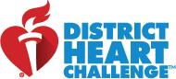

Our district is proud to participate in the American Heart Association’s District Heart Challenge!
We want to inspire staff to be active and learn about how to keep our hearts healthy.
By partnering with the American Heart Association, we will raise awareness and help fight heart disease and stroke,
the No. 1 killer and No. 5 killers of Americans.

On Friday, February 5th, National WEAR RED DAY, we will GO RED to support the mission of the American Heart Association – building healthier lives free of cardiovascular diseases and stroke. Throughout this school year, you will receive monthly emails on a variety of health topics and learn simple ways you can make big changes with your health.

We will be asking EVERYONE in our district to GO RED on Friday, February 5th!
Here’s a sneak peek at the 2020-2021 American Heart Association T-Shirt!  Here’s how to donate!  From your phone, TEXT EASTPOINTEGIVES to 41444.  You will immediately receive a donation link specifically for our  school district. | 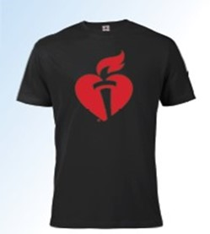  T-shirts are earned at the $20 donation level and ALL proceeds benefit the American Heart Association  and its mission.

