PLEASANTVIEW AND FOREST PARK ROUTES

7362-F
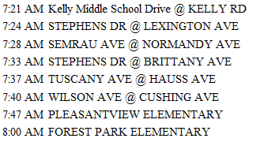

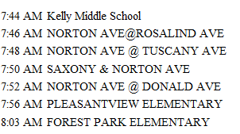
7422-G

7365-H
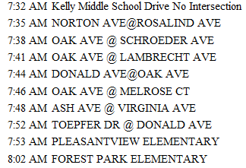

Page 1 of 2

PLEASANTVIEW AND FOREST PARK ROUTES

BUS: 7420-K
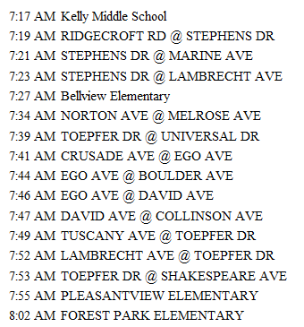

Page 2 of 2

