EASTPOINTE MIDDLE SCHOOL
Bus: 7362-F
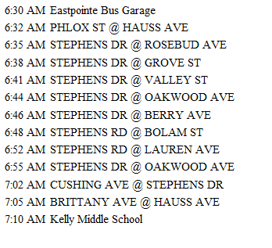

Bus: 7422-G
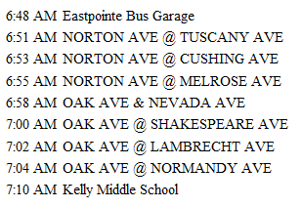

Page 1 of 2

Bus: 7365-H
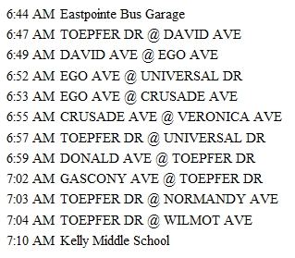

Bus: 7420
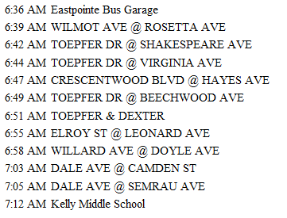

Page 2 of 2

