BELLVIEW AND CRESCENTWOOD ROUTES

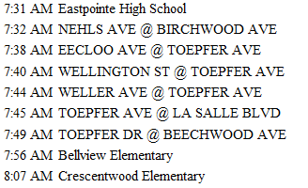
BUS: 7417-I

BUS 7418-J
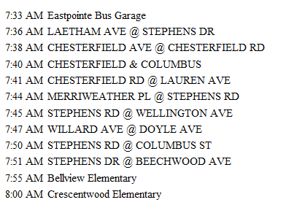
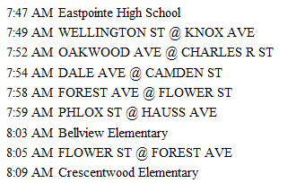
BUS 7415-N

