EASTPOINTE HIGH SCHOOL
Bus: 7417-I
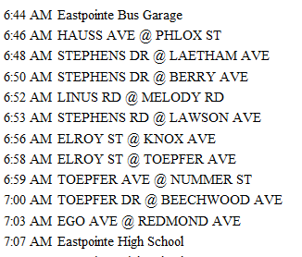

Bus: 7415-N
